PORTFOLIO

Submitted by

# KHUSHI TIWARI [Reg No: RA2111003011709]

***for the course 18CSC204J Design and Analysis ofAlgorithms***

*Under the guidance of*

# Dr. SINDHUJA M

Assistant Professor, Department of Computing Technologies *in partial fulfilment for award of the degree*

*of*

BACHELOR OF TECHNOLOGY

in

# COMPUTER SCIENCE AND ENGINEERING

of

## FACULTY OF ENGINEERING AND TECHNOLOGY



S.R.M. Nagar, Kattankulathur, Chengalpattu District

APRIL 2023

|  |  |
| --- | --- |
| STUDENT PORTFOLIO | |
|  | Name: Khushi Tiwari  Register Number: RA2111003011709  Mail ID: kt2638@srmist.edu.in  Department: Department of Computing Technologies  Specialization: Computer Science and Engineering Semester: IV |
| Subject Title: 18CSC204J Design and Analysis of Algorithm.  Handled By: Dr M. Sindhuja | |
| Assignment – Crossword Puzzle  Crossword is always a way we can analyse how quick and knowledge we have on the topic. The assignment topics also helped me analyse my knowledge about DAA, I have learnt so far. Firstly, I picked up question that I knew answers of and then after writing it down the dots started to connect for the other question as well.  The assignment was very helpful in making us learn new terms and topics in DAA. DAA being an important part in every step towards are future being for placement’s and other  stepping stone this assignment has been fun and learning assignment that will be helping us in our future. | |

|  |
| --- |
|  |
| Assignment  (What is the most interesting part in the assignment)  The most interesting part in the assignment being its layout and working system.  Every across and down is clearly portrayed and the backend in making it is very clean and systematic.  This is assignment was an engaging new concept that I enjoyed doing in. |
| Achievement |

Github(Repositories)

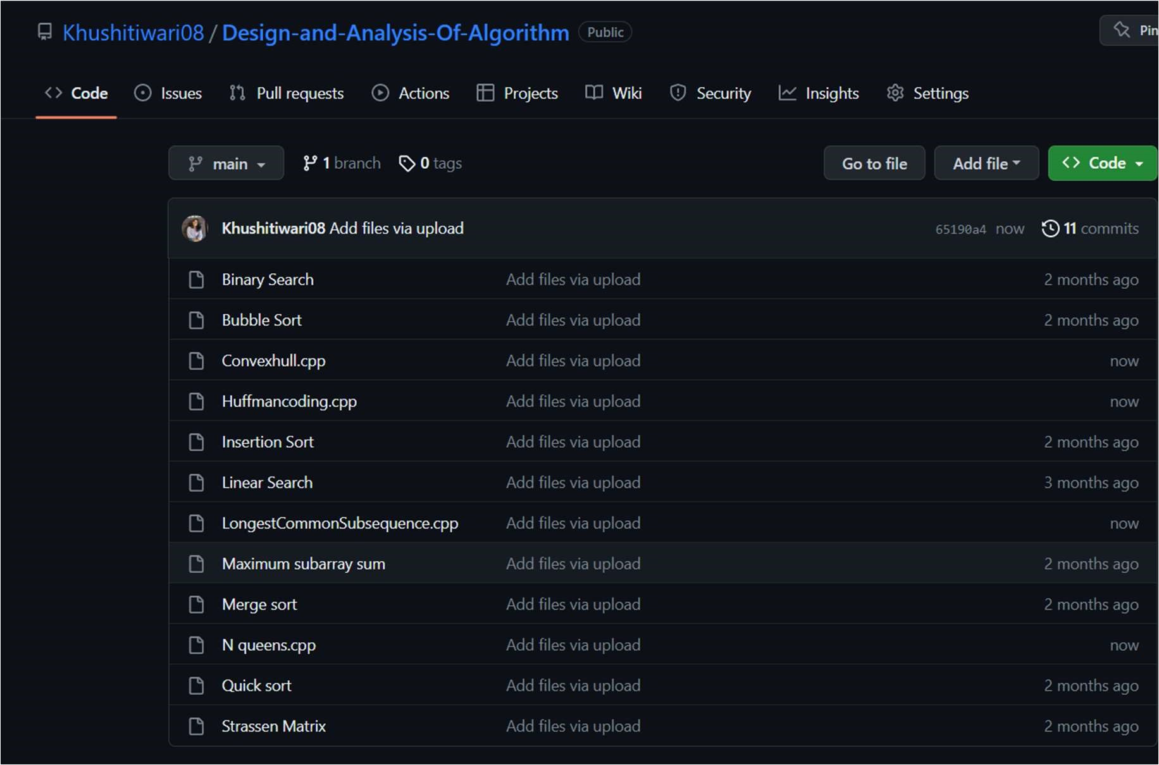

Signature